 | COUNTY OF CARROLL  OFFICE OF THE COMMISSIONERS  Administration Building  95 Water Village Road Box #1  Ossipee, New Hampshire 03864  Phone 603-539-7751 Fax 603-539-4287  Commissioners@CarrollCountyNH.net  www.CarrollCountyNH.net | 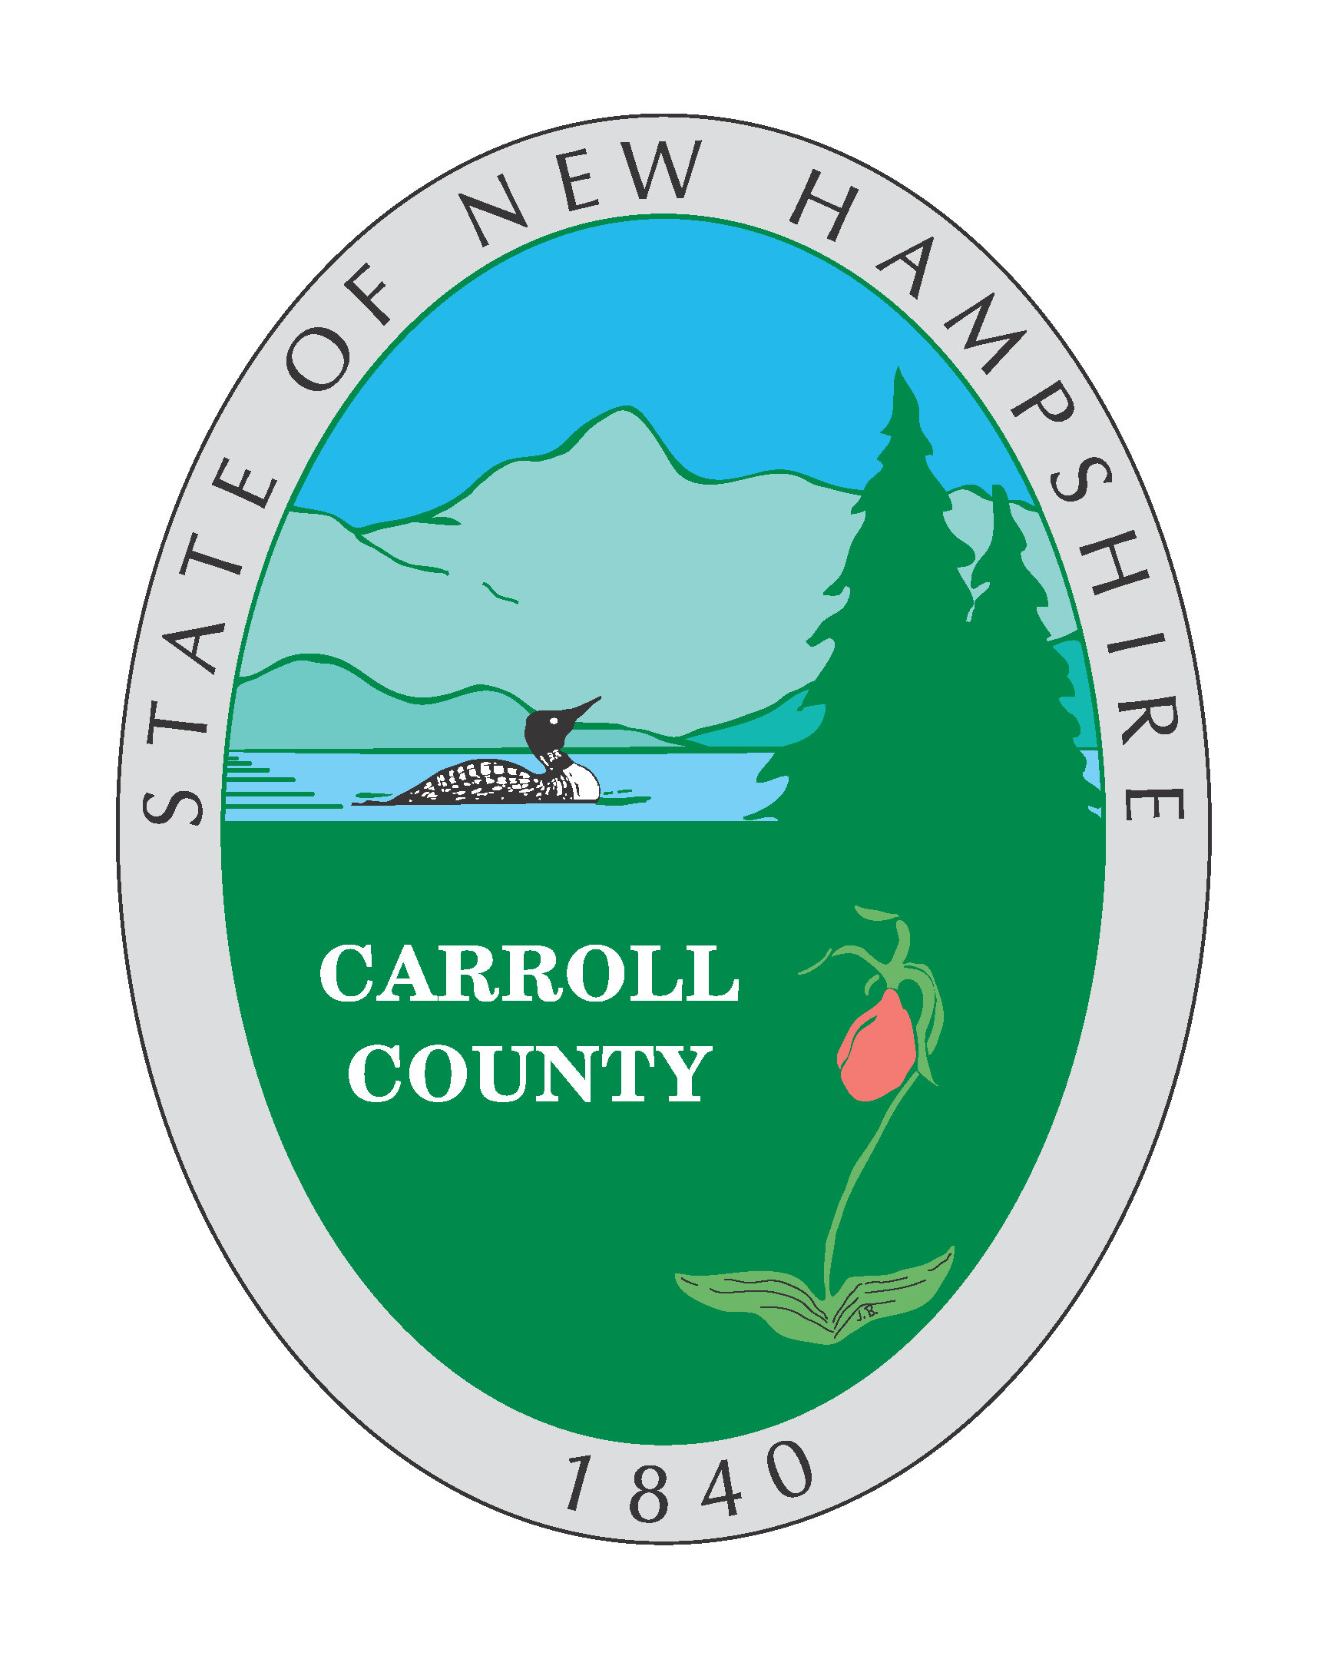

Policy Title: | Right to Know Policy
Policy Number:
Purpose:
Effective Date: | 02/04/2015
Revision Date: | 07/15/2020
Reference(s): | NH RSA 91-A

POLICY
The purpose of this policy is to empower the citizens of Carroll County by ensuring the timely provision of information necessary to effectively participate in democratic process. The Board of Commissioners is committed to conducting the business of county government openly and transparently, within the parameters of the law, in order to ensure the greatest possible access and accountability to the people of the County. It is the policy of the County to facilitate public access to existing governmental records, as governmental records are defined under RSA 91-A, and where such access is required under RSA 91-A. However, the County is not required to create records of any kind or to compile lists, graphs, or others documents to answer questions or to satisfy such a request.

How to Make a Request

Any person may ask to inspect governmental records. Requests for the inspection of governmental records shall be directed to: Carroll County Commissioner’s Office at 95 Water Village Road in Ossipee, New Hampshire. The Office has normal business hours, which are 8:00 a.m. to 4:00 p.m., Monday through Friday, excluding holidays. Due to the varying nature and time restrictions of tasks performed by the Office, it is always suggested, but not necessary, to call ahead or to schedule an appointment. The place of inspection shall be the place where the document is located, unless the Commissioners or their designee determines that another place of inspection is more appropriate.

Requests may be made verbally or submitted in writing. Electronic requests may be sent in via the County website (www.carrollcountynh.net) using the “Contact Us” button or through the commissioners’ email at commissioners@carrollcountynh.net

The Right-to-Know law does not require a person making a request to identify themselves, and imposes no restrictions on the use of the information being disclosed. However, persons submitting a request via email or through the County website must include return contact information in order to receive a response.

Response to Request
Governmental records which are subject to disclosure under NH RSA 91-A, and which are immediately available will be provided for inspection upon request whenever possible.
- Staff will ask the requestor to wait while the records are made available
- Where a copy does not exist and an original is required for inspection, handling of the original document shall be monitored closely by staff at all times
- Single copies of single page documents may be made upon request for a fee of $.75 per page. Multi-page documents will incur a higher fee and may require additional time

Often, governmental records may not be immediately available because, among other reasons, they are: a) already in use; b) must be reviewed or redacted; or c) must be reviewed further by legal counsel prior to a determination concerning disclosure.

In accordance with NH RSA 91-A:4, IV (a), if the County is unable to make the governmental record available for immediate inspection and copying, the County shall, within 5 business days of the request 1) make the record available; 2) deny the request, in writing, citing the specific exemption authorizing the withholding of the record and a brief explanation of how the exemption applies to the record withheld; or 3) provide a written statement of the time reasonably necessary to determine whether the request shall be granted or denied and the reason for the delay.

No cost or fee shall be charged for the inspection or delivery, without copying, of governmental records, whether in paper, electronic, or other form.

In lieu of providing original records, the County may copy governmental records requested to electronic media using standard or common file formats in a manner that does not reveal information which is confidential under the law.

Access to work papers, personnel data and other confidential information under NH RSA 91-A:5, V shall not be provided. The County is not required to compile, cross-reference, or assemble information into a form which is not already kept or reported.

If, for practical reasons, the County is unable to copy a requested governmental record, the County will make arrangements with public or private facilities. The County shall collect from the requestor the fee for the actual cost of the copy, or the requestor may choose to pay the cost of reproduction directly to the copying facility.

If the requestor requests that a copy be mailed, the requestor will be charged the actual cost of postage or delivery and must prepay those costs.

Approved and adopted into practice this ________ day of _______, 2020, by vote of the Carroll County Board of Commissioners.

Amanda Bevard Terry McCarthy David Babson
Chairman Vice-Chairman Clerk

