COUNTY OF CARROLL
OFFICE OF THE COMMISSIONERS

Administration Building
P.O. Box 152, 95 Water Village Road
Ossipee, New Hampshire 03864-0152
Phone 603-539-2428 Fax 603-539-4287

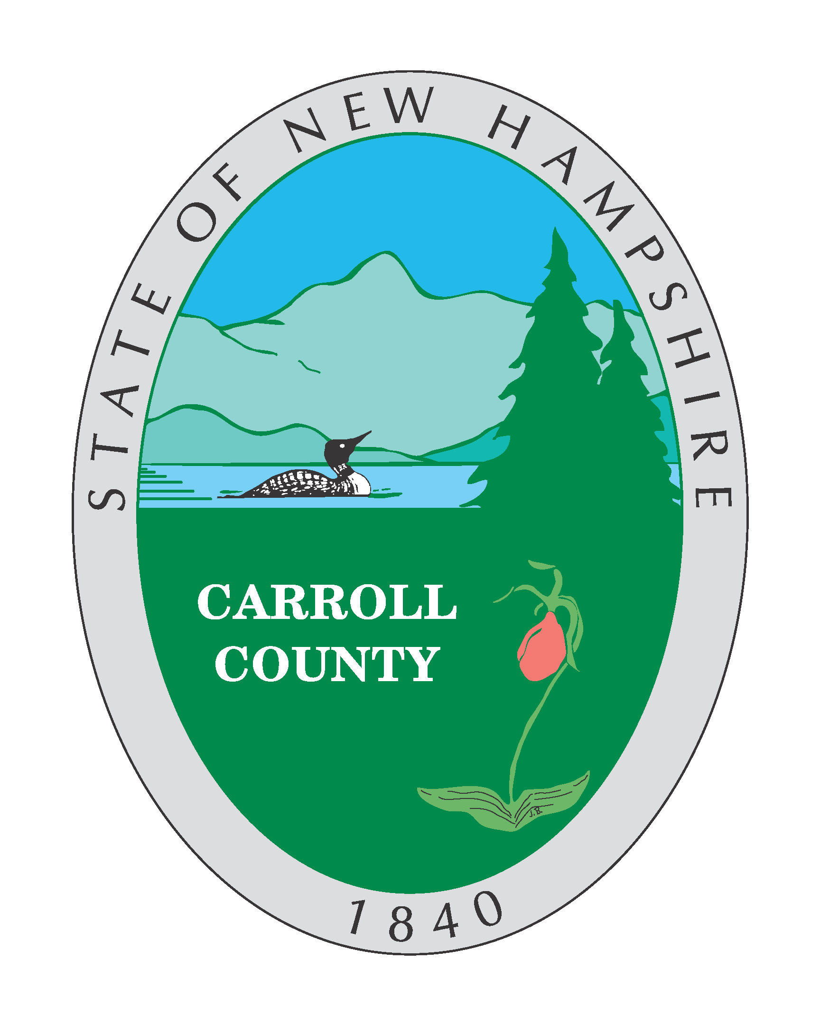

RFP for

CCDOC installation of video cameras

1. Introduction

The County of Carroll, NH proposes to engage the services of a company that can supply, installation, and wiring of 6 Dome and 12 Stationary Digital Video Cameras for the Carroll County Department of Corrections, at 50 County Farm Rd. Ossipee, NH.

2. Submission Details

A completed proposal shall be submitted to the Carroll County Commissioners Office, 95 Water Village Rd, Ossipee, NH 03864.
All submissions shall be received before 4:00 pm, Thursday May 20, 2021.

Each proposer must submit one (1) original, and (3) copy of their proposal.

The County reserves the right to cancel this Request for Proposal for any reason without any liability to any proponent or to waive irregularities at their own discretion.

Proposals may be withdrawn by written notice only provided such notice is received at the Carroll County Business Office prior to the date/time set as the closing time for receiving proposals.

Any interpretation of, additions to, deletions from, or any other corrections to the Proposal document, will be issued as written addenda by the County of Carroll.

Proposals will be evaluated post bid opening by the Carroll County Superintendent, and bid recommendation (if any) will be made upon satisfactory submission of bid, and possible interviews to determine and clarify the experience and responsibility of the proposer. The Superintendent will make a recommendation to the Carroll County Commissioners, who will make the final decision to select the contractor.

Carroll County reserves the right to accept or reject any and all bids for any reason, and award bids deemed most advantageous to the County.

Except as expressly and specifically permitted in these instructions, no proponent shall have any claim for any compensation of any kind whatsoever, as a result of participating in the RFP, and by submitting a proposal each proponent shall be deemed to have agreed that it has no claim.

3. Inquiries

Clarifications of terms and conditions of the proposal, as well as requests for existing details, and scheduling of mandatory site visit for all submitting vendors shall be directed to:

Sean Eldridge
Superintendent
Carroll County DOC
50 County Farm Rd
Ossipee, NH 03864
603-539-2282 Ext 1000
seldridge@cchoc.org

4. Project Schedule

The project start date shall be determined after the notification of the award. However, it is anticipated to be prompt.

5. Working Agreement

The successful proponent will enter into a contract for the purchase with the County based upon the information contained in this request for proposal and the successful proponent’s submission and any modifications thereto.

6. Detailed Requirements

A site visit, to determine scope and suitability of installation prior to bid submittal is mandatory. Proposals shall be evaluated to determine the best value offered to the County. All bidders shall be responsible to ensure that their submitted proposal is correct and complete. All costs associated with purchase, procurement, delivery, and installation shall be assumed to be included in any submitted proposal.

The Digital management system shall be fully integrated into the current Enterprise Building Integrator (EBI) system, which allows viewing and digital recording of video from network connected cameras through the SMS user interface.

If any extra costs are discovered after submission of bid, and contract is awarded, it shall be the responsibility of the submitting bidder to absorb these costs.
Removal/disposal/recycling/refurbishing for resale, or any combination of the above shall be the sole responsibility of the winning bidder.

7. Proposal Information

Please mail or hand-deliver proposals to:

Carroll County, Office of the Commissioners
Mellisa Seamans
Attn: Carroll County Dept. of Corrections Video Cameras
95 Water Village Rd
Ossipee, NH 03864
603-539-7751 ph
mseamans@carrollcountynh.net

Proposals must be received no later than 4:00 pm, Thursday May 20, 2021
Bids will be opened at next scheduled meeting of the Commissioners

